Tahiti

Tahiti is the largest island in the Windward group of the French Polynesia, located in the archipelago of Society Islands in the southern Pacific Ocean. The capital is Papeete, on the northwest coast. Tahiti has also been historically known as O'tahiti.

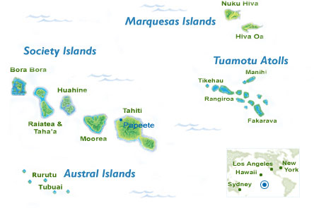

VISA The visa is to be obtained prior to arrival in the country

HOW TO GET THERE:
INTERNATIONAL AIRPORT: The Tahiti Faa'a Airport on the island of Tahiti is the one and only international airport servicing French Polynesia.

FLIGHTS INTO TAHITI:
Tahiti is an easy 7 1/2 hour direct flight from Los Angeles and just south of the equator, midway between Australia and South America.
It is in the same time zone as Hawaii, but because it is in the Southern Hemisphere, the seasons are reversed.

CURRENCY:
The currency used in French Polynesia is the Franc of the "Compagnie Française du Pacifique" usually called French Pacific Franc. Its abbreviation is XPF or CFP.
Its exchange rate with the Euro is fixed flat rate (no fluctuation).

1 Euro (€) = 119.33 Pacific Franc (XPF)
1 US dollar = 86 Pacific Franc (*)
1,000 Pacific Franc = 11.62 US dollars (*)

(*) Approximate exchange rate in July 2007

GETTING AROUND:
Because of its larger size and population, the island of Tahiti has many transportation options.
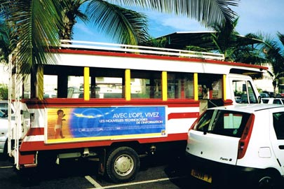
Le Truck in Tahiti

Bus: To get around Papeete and the surrounding towns, the public transit system offers two bus services: the open-air Le Truck allows frequent stops and a unique way of meeting the locals, it is undoubtedly the most economical way to travel throughout Tahiti, and Prices are around $1.25 francs for any location on the island! Perhaps the best deal you'll get in all of French Polynesia... while the large white RTC motor coaches offer 26 routes. From your hotel to downtown Papeete, some hotels have courtesy buses. Escorted circle-island bus or 4x4 tours are the ideal way to explore the points of interest around Tahiti's coast and within the interior valleys
Taxi: Local Taxi service is also good, but can be quite spendy depending on your destination. A simple 10 minute ride from the airport to your nearby hotel can run you $20.00 or more. Nevertheless, taxis are numerous and quite dependable and a common form of transportation, especially in Papeete. Once in downtown Papeete, most of the attractions, restaurants, and shopping are within walking distance.
Rentals Car, scooters & bicycles: Is perhaps the most popular form of getting around Tahiti, because they offer the most freedom. They are a great way of seeing Tahiti, but not necessarily the most economical. If you haven't pre- arranged a rental car with your hotel, (recommended), you will most likely be able to book one direct from the airport, provided they have cars available. Renting motor scooters and bicycles by the day or week is also an option.
Others: island can be explored by motorboat and yacht charters, outrigger canoe tours, and helicopter tours.

BUSINESS
Business etiquette is relatively informal in Tahiti and French Polynesia. French is the main language of trade; however English is often understood in more touristy areas. Business hours are generally 8am to 12pm and 1.30pm to 5.30pm Monday to Friday.

CLIMATE
French Polynesia enjoys tropical, warm and humid weather all year round, averaging eight hours of sunshine per day over a year. The islands experience a rainy season, generally between late October and early March, when cloudy skies and brief heavy rain showers can occur. The rest of the year rain is rare and temperatures constantly high, tempered sometimes by refreshing breezes. The water temperature ranges from 26°C to 29°C making for extremely pleasant bathing all year round.

CLOTHING
Casual, informal dress is standard in Tahiti. Lightweight, washable cottons are suggested for greatest comfort.
Men are most often dressed in shorts (possibly slacks for dinner), sport shirts or T-shirts, sandals or tennis shoes.
Woman can wear everything from shorts to skirts to sun dresses to pareos (wrap-around cloth garment). Pareos are brightly colored and versatile hand blocked or painted fabrics 2 yards long by 1 yard wide, and are worn at home, the beach, and around the hotel pools. Some are elegantly tied for eveningwear. Pareus are not recommended for downtown Papeete, as the city is rather cosmopolitan in dress code. Bathing suits and short shorts are also out of place in Papeete. We recommend taking along a couple of swimsuits each, rubber-soled shoes for walking on coral, hat or sun visor, sunglasses, and waterproof bag

TIME
Tahiti is 15 hours and 35 mins behind us

ELECTRICITY
The electric current in most hotels is 110/220 volts AC, 60 Hz. American-style two-pin flat blade plugs and a round pin plug and receptacle with male grounding pin are used.

DIALING CODE
The country code for French Polynesia is +689 and the outgoing code is 00, followed by the relevant country code (e.g. 0027 for South Africa). City/area codes are not in use.

LANGUAGE
French and Tahitian are the official languages; English is widely spoken.

TIPPING
Tipping in Tahiti and the islands is not required - nor expected - as it goes against local custom where hospitality is paramount. All prices quoted are all-inclusive.

SAFETY
Visits to French Polynesia are usually trouble-free. The crime rate is low, but sensible precautions should be taken with valuables. Tropical storms and cyclones can occur between November and April.

HEALTH
A yellow fever vaccination is required for travellers to French Polynesia arriving from an infected area. Immunization against hepatitis A is recommended, and the territory is subject to increasing outbreaks of dengue fever. A typhoid vaccine is also suggested for most travellers (except short-term business travellers or cruise ship passengers). Tap water in hotels is safe to drink, but bottled water is also freely available throughout the islands. Tahiti has good health facilities with pharmacies and a large government hospital. There are a few private doctors and clinics in the outer islands. The only decompression chamber is at Papeete. Medical insurance is recommended for travellers.

PAPEETE
Papeete is a unique city like no other in the world. French Polynesia's capital and center of business. In Papeete, you’ll find a modern, bustling port, with shopping ranging from black pearl boutiques to island handicrafts to the latest in French fashions. Sip a drink and people-watch at a sidewalk café, or savor the delicate flavors of French cuisine. On Moorea, jagged peaks, deep valleys, cascading waterfalls and breathtaking bays make a stunning backdrop for your tropical adventure. Bora Bora has been called the most beautiful island in the world. Its lagoon, a haven for watersports, ranges from palest turquoise to deepest blue. Paradise found!

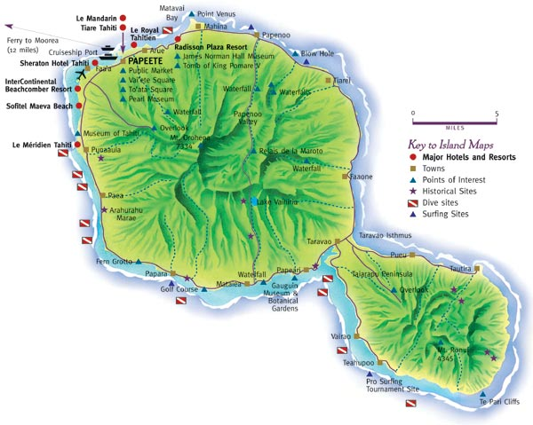
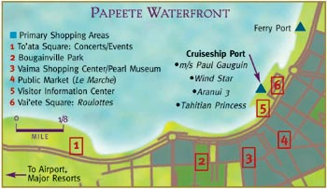

SIGHTS ON TAHITI

Circle-Island Tour
A favorite among visitors for over 100 years! Over 71 miles of dramatic coastline scenery with wave-pounded cliffs, peaceful beaches, and rightly colored churches. Popular stops include botanical gardens, waterfalls, and ancient temples. Explore the tiny villages and panoramic vistas of the remote and beautiful peninsula of Tahiti Iti with an extended tour.

Museum of Tahiti
The lagoon setting and historical displays makes this one of the best and most beautiful museums in the South Pacific. Polynesian history, religion, and culture before the arrival of the explorers and missionaries is carefully recorded and presented. Highlights include rare collections of paintings, sculptures, ancient canoes, and historical artifacts.
Open Tuesday - Sunday- 9:30am- 5:30 pm.
Closed Monday, ADMISSION FEE

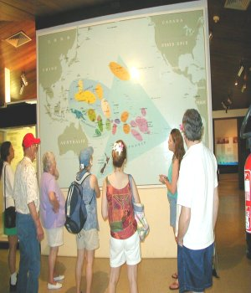
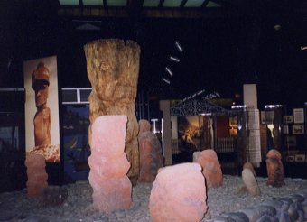
James Norman Hall Home
The residence of one of Tahiti's famous resident authors, James Norman Hall, is maintained as it was when he lived in Tahiti from 1920 to 1951. Hall is best known for Mutiny on the Bounty which he co-authored with Charles Nordhoff. Visitors see his original writing desk, art collection, and library with 3,000 books. Guests are invited to enjoy tea in the garden under the terraced mango tree.
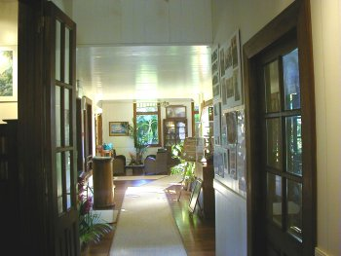
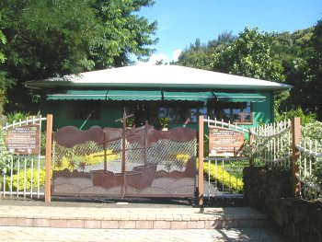
The Gauguin Museum
Dedicated to Paul Gauguin's life during his years on the island of Tahiti and in the Marquesas, the museum features exhibits and memorabilia from the late painter himself, including sketches, copies of documents, block prints, and reproductions of many of his most famous paintings.
Open daily from 9am- 5pm. FREE ADMISSION

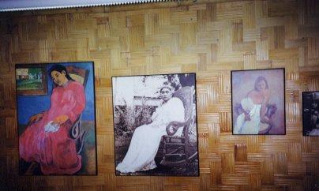
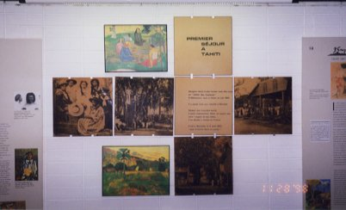

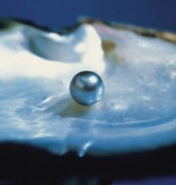
Pearl Museum
The only museum in the world devoted entirely to pearls. The unique presentations about Tahitian Cultured Pearls describe and demonstrate the history and practice of cultivating pearls as well as their place in art, history, mythology, and religion.

Bougainville Park
In the heart of the waterfront area, visitors find a newly renovated and peaceful oasis. Crowned by a massive banyan tree, the park is named in honor of the French explorer and navigator, Louis Antoine de Bougainville (1729-1811) and features running streams and lush vegetation

Botanical Garden
Adjacent to the Gauguin Museum, this lush and manicured garden features hundreds of varieties of tropical trees, plants, and flowers including bamboo, bananas, palms, and hibiscus. The garden was originally planted by American botanist Harrison Smith who moved to Tahiti in 1919.
Open daily 9 am to 5 pm
Free Admission

Evenings at Vai'ete Square
A must for every visitor unfolds every evening on the waterfront at Vai'ete Square. Here, dozens of colorful roulottes, or food wagons, host a great variety of island cuisine and desert. Visitors can enjoy a unique and informal dinner or a memorable post-dinner desert in a lively setting not to be missed.

Point Venus
At the tip of a beautiful peninsula lined with black-sand beaches, this area was the historic landing site of many of the early explorers including Captain Cook and Captain William Bligh. Tahiti's only lighthouse, built in 1867, stands within a park popular with locals for community events and festivals.

ACTIVITIES IN TAHITI

Safari Into the Island's Interior
Within the unpopulated and lush jungle-like interior of Tahiti Nui is an unspoiled world of towering waterfalls, deep flower-filled valleys, large lakes, and colossal green peaks rising over one mile above the valley floor. This hidden treasure of Tahiti is best explored by a guided 4X4 safari, breathtaking helicopter tour, or on a hiking trip led by a naturalist.
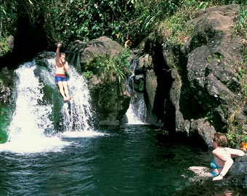
Nature Tour in Tahiti
Golfing
Tahiti's only course, the Oliver Breaud International Golf Course is located on the southern side of Tahiti Nui. This 6944-yard, par 72 course features two man-made lakes and sprawling fairways. Formerly a cotton plantation, the course was recently renovated and now includes a new clubhouse, driving range, pool, restaurant, pro shop, and tennis courts.

Hiking/Nature Tours
Adventurous travelers will love the exciting guided tours that lead into rugged interior. Stops can include spectacular waterfalls and natural pools (some in which you can swim), mountain peaks with panoramic views, archeological sites , grottos, and lava tubes.
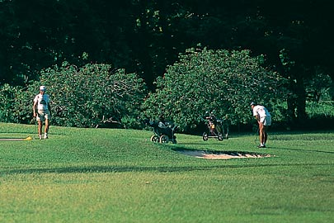
Diving
Tahiti has many dive sites and operators around the island and is perfect for both beginning and advanced divers. Highlights include clear, shallow waters, sunken vessels, and large schools of smaller species.
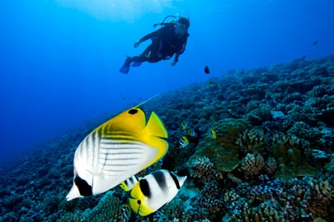

Horseback Riding
For the horse enthusiast Tahiti has a number of first-class riding stables. Experienced riders can saddle-up the island's New Zealand and Marquesan horses, while private lessons are available for the beginner. Rides in the mountains are often accompanied by picnic lunches.
Shopping at Le Marché
Discover the true heart of Papeete at the 153 year old public market called Le Marché. Shop from hundreds of stands filled with Tahitian-made crafts, oils, vanilla, fruits, and flowers. Located two blocks from the waterfront across from the cruise dock, the market is the perfect place to find everything imaginable from all the islands. Those visitors in Tahiti on the weekends should plan a visit on Sunday mornings where the market is the most colorful and lively.
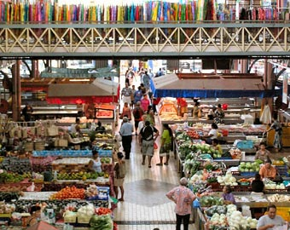
Le Marche de Papeete

Shopping in and around the Vaima Center
Many shops popular with visitors are located in and around the Vaima Center. This four-level, block-square shopping center has everything from boutiques, pearl shops, book stores, newspaper stands, restaurants, coffee shops, and banks. Along the waterfront in either direction are located many unique shops with antiquities, made-in-Tahiti products, music, and art.

Other activities and sites in Papeete and around the island:
Deep sea fishing
Lagoon excursions on outrigger canoes or powerboats
Notre Dame Cathedral of Papeete
Papeete Town Hall
Drive to the Belvedere overlooking Papeete
4X4 Safari from Faa'a into the high mountains
Tomb of Queen Pomare V and Royal Family
Arahoho Blowhole
Waterfalls and walking trails at Faarumai
Vaipahi Gardens
Maraa Fern Grotto
Marae Arahurahu
Surfing sites at Teahupoo, Papara and Taapuna
Guided hike to the top of Mt. Aorai
Guided hiking trips into the remote Pari Region of Tahiti Iti

Guided or self-guided itineraries including these and other sites can be pre planned before you travel or at the activities desk of your resort or cruise ship.

Family Time on the Island of Tahiti

The island of Tahiti offers a world of adventure for families and for children of all ages. Whether here for a day or a week, the urban and island environment provides the perfect blend of accommodations and activities designed for family fun and enrichment.
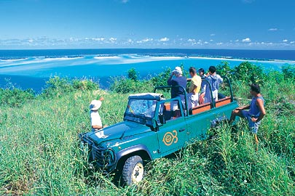

Popular family activities include:
- Large swimming pools with sand bottoms at the lagoon-side resorts with fountains, islands, and waterfalls.
- White- and black-sand beaches to enjoy snorkeling in the shallow, warm, and calm lagoon waters.

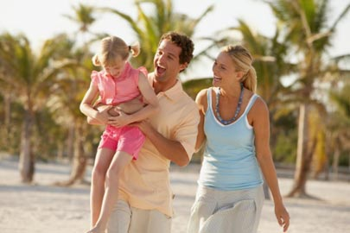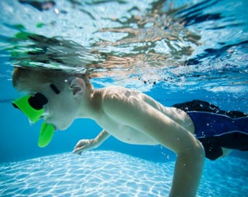

Family-sized 4X4 safari vehicles that fit up to eight people for half-and full-day expeditions into the lush interior for exploration and a picnic under a waterfall.
- Guided hiking and boating excursions with a naturalist who provides a close up study of the bird, plant, and marine life.
- Tours of the museums and points-of-interest around the island with exhibits of interest for the whole family about geology, art, history, and exploration.
- Regular public performances of elaborate and colorful music, sport, and dance featuring local children of all ages.
- Nightly outings along the festively-lit Papeete waterfront where the roulottes offer a fun way to enjoy an informal dinner and dessert alongside hundreds of local families and their children.
SAMPLE ITINERARY

Day One
Discover the Real Papeete
- Shopping at the market and at the colorful shops all along the waterfront.
- Walking tour of Old Papeete.
- Pearl shopping and visit to the Pearl Museum.
- Visit art galleries and exhibits.
- Hear joyous singing at a church.
- Enjoy dinner at the roulottes in the vibrant waterfront area of Vai'ete Square.
Day Two
Take a Road Trip in Paradise
- Circle the island by bus or car.
- Picnic on a black-sand beach.
- Explore high waterfalls by helicopter.
- Tour the museums around the island.
- Take a safari by 4X4 deep into the valleys.
- Hike with a guide up Aorai Mountain.
- Dine at one of the resort restaurants.
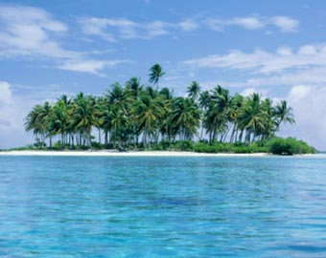
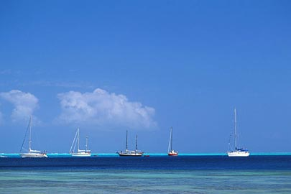

Boats in Tahiti Lagoon Tahiti Beach
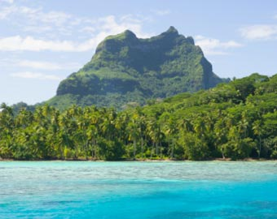
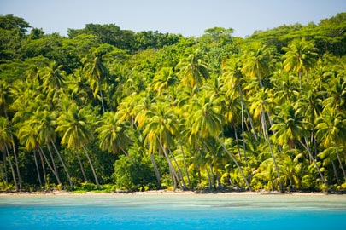
Day Three
Day Trip to Moorea
- Take a safari by 4x4 into the interior.
- Visit a fruit tasting factory.
- Shop for crafts made in Moorea.
- Return to dine at one of the local favorites around Papeete or at one of the world-class restaurants in the resorts.
Day Four
Water World
- Snorkel in the clear waters around the resorts
- Hire a dive master and learn to dive or to explore the sunken vessels and coral
- Canoe or kayak in the lagoon
- Fish the deep sea for marlin
- Charter a sailing catamaran
- Windsurf, waterski, or jetski
- Swim in the famous grotto
Tahiti Beach Tahiti Mountains
HOTEL STAY IN PAPEETE
Most properties are located in or near Papeete and are a short taxi or coach ride away from both the airport and the cruiseship and ferry docks.

Hotel Tiare Tahiti
InterContinental Resort Tahiti
Le Meridien Tahiti
Le Royal Tahitien
Radisson Plaza Resort Tahiti
Sheraton Hotel Tahiti
Sofitel Tahiti Resort
Tahiti Airport Motel

Small Hotels & Lodgings in Private Homes
Federation Haere Mai (Guesthouses & Pensions)

Tahiti
Chez Maithe
Fare Ratere
Hiti Moana Villa
Pension Au Bonjouir
Pension De Famille Chayan
Pension De La Plage
Pueu Village
Taaroa Lodge
Te Nahe Toe Toe
Vanira Lodge
Village Punatea

